EAE BUSINESS SCHOOL
Master in Big Data & Analytics
Data Science

Bicing Demand & Occupancy Analysis
Predicting Station Occupancy Across Barcelona's Bike-Sharing Network

Tiago Garrel
Ma. Inés Montans
Natalia González

1. Business Understanding 3
1.1 Definition of the Project Objectives 3
1.2 Requirements 3
1.3 Business Context and Expected Use 3
2. Exploratory Analysis and Data Understanding 4
2.1 Data Description 4
2.2 Data Visualization 4
2.3 Attribute Analysis and Data Statistics 6
2.4 Outlier Analysis and Strategy 6
2.5 Missing and Erroneous Data Strategy. 6
3. Data Preparation 8
3.1 Data Cleansing Process 8
3.2 Feature Engineering 8
4. Modelling 10
4.1 Task Type 10
4.2 Model Selection 10
4.3 Theoretical Introduction to the Models 10
4.4 Hyperparameter Tuning 10
5. Evaluation 12
5.1 Results 12
5.2 Validation Against Business Objectives 13
5.3 Interpretation, Contextualisation, and Error Costs 14
6. Model Iteration: LightGBM V2 16
6.1 Motivation 16
6.2 Feature Engineering Changes (V2) 16
6.3 Hyperparameter Search: Two-Phase Optuna 16
6.4 Results 16
7. Deployment 17
7.1 Proposed Production Architecture 17
7.2 Model Usage 17
7.3 Model Evolution and Monitoring 18
References 19

1. Business Understanding

1.1 Definition of the Project Objectives
Bicing is Barcelona's public bike-sharing system, operated by the city council and used daily by tens of thousands of commuters and leisure riders. One of the core operational challenges any bike-sharing system faces is fleet rebalancing: bikes tend to accumulate at downhill or destination stations while departure stations run dry. Correcting this imbalance requires trucks to physically move bikes, a process that is both costly and reactive.
The goal of this project is to build a supervised regression model that predicts the occupancy fraction of any Bicing station at a configurable time horizon into the future. Formally, given the state of station S at time T, the model predicts the fraction of its docks that will be occupied at T+h, for h in {1, 3, 6, 12, 24} hours. A prediction of 0 means empty; 1 means full.
Rather than training a separate model per horizon, a single model receives horizon_hours as an explicit input feature. This design enables deployment at any supported horizon without retraining, and allows the model to learn internally how uncertainty grows with distance into the future.

1.2 Requirements
For the model to be useful in practice, predictions must generalise to data the model has never seen during training: November and December 2024 are held out entirely, simulating a deployment scenario. The model must also perform meaningfully better than naive alternatives (assuming occupancy will stay constant, or using a long-run historical average) to justify the engineering overhead of deploying it. A third requirement is explainability: operational staff needs to understand, at least at a high level, why a station is flagged as likely to overflow or empty out.
On the data side, three sources are required: the Open Data BCN portal for historical station snapshots (published monthly as compressed .7z files), the Open-Meteo historical weather API for hourly temperature, precipitation, and wind speed, and the Python holidays library for the Catalan public holiday calendar. All sources are free and publicly accessible.

1.3 Business Context and Expected Use
If integrated into the operations workflow, the model could feed two use cases.
- In an analyst-assisted mode, fleet managers would review a dashboard of predicted high-risk stations each morning and dispatch rebalancing trucks accordingly, turning a reactive process into a proactive one. In a more automated mode, the predictions could directly trigger logistics recommendations for which stations should be topped up before peak hours.
- In a user-facing mode, the Bicing mobile app could display predicted availability at a destination station, allowing users to plan alternative routes when a station is predicted to be full on arrival.
The model covers all 510 active stations across Barcelona in 2024. A single API call with a station ID, a timestamp, and a horizon returns a predicted occupancy that can be refreshed as conditions change throughout the day.

2. Exploratory Analysis and Data Understanding

2.1 Data Description
The primary dataset comes from Open Data BCN, which publishes the real-time status of every active Bicing station approximately every 5 minutes. All twelve monthly files covering January through December 2024 were downloaded and processed. Each record contains the station ID, a Unix timestamp, the numbers of mechanical and electric bikes available, the total number of bikes, the number of available docks, and an operational status flag. Only records with status IN_SERVICE were retained.
After loading all twelve months, the raw snapshots were aggregated to hourly means per station. The station information file provides GPS coordinates and dock capacity per station. Weather data was fetched from the Open-Meteo historical API for Barcelona's coordinates. Catalan public and local holidays were retrieved via the Python holidays library.
The merged dataset covers 510 stations across the full year, from January 7 to December 31, 2024 (the first week is lost to lag feature construction, which requires at least 168 hours of history per station). After expanding to five prediction horizons, the modelling dataset contains 20,142,030 rows.

2.2 Data Visualization

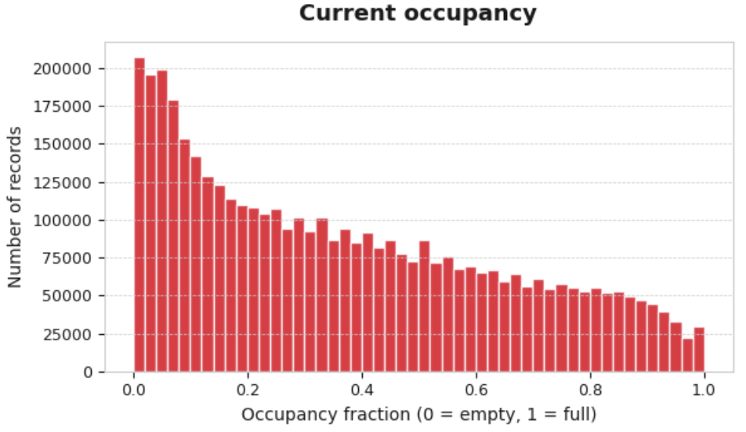
Figure 1. Distribution of current occupancy (left) and target occupancy at T+6h (right).
The occupancy distribution across Barcelona's Bicing stations is strongly right-skewed, with the highest frequency of observations concentrated at very low occupancy levels (0.0–0.1). This indicates that stations spend a disproportionate share of time near-empty, meaning available bikes are scarce for most observed station-hours. Frequency declines steadily as occupancy increases, though a modest secondary cluster around 0.3–0.6 suggests some stations do sustain moderate availability, likely during off-peak hours or following rebalancing. A non-trivial count at occupancy = 1.0 points to stations occasionally reaching full capacity, which creates the opposite problem: no docks available for returns. Together, the distribution reveals a system under asymmetric pressure, with empty stations being a far more common failure mode than full ones.
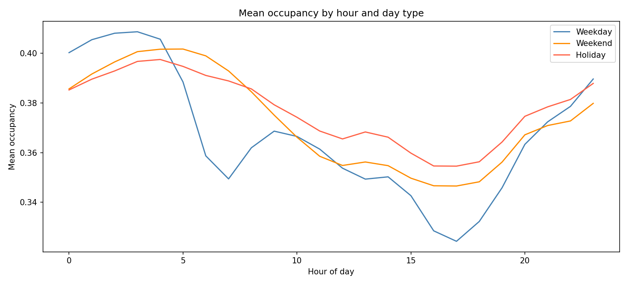
Figure 2. Mean hourly occupancy by day type. Weekdays show a clear double-peak commuter pattern; weekends peak later and hold a flatter profile.
The hourly breakdown by day type captures the dominant temporal structure of the dataset. On weekdays, occupancy spikes between 7 and 9 AM and again starts increasing in the late afternoon, a clear commuter signature. Weekend and holiday profiles are smoother, and usage peaks (low occupancy) occur in the early afternoon. This pattern motivates the use of cyclic hour and day-of-week encodings rather than raw integers.
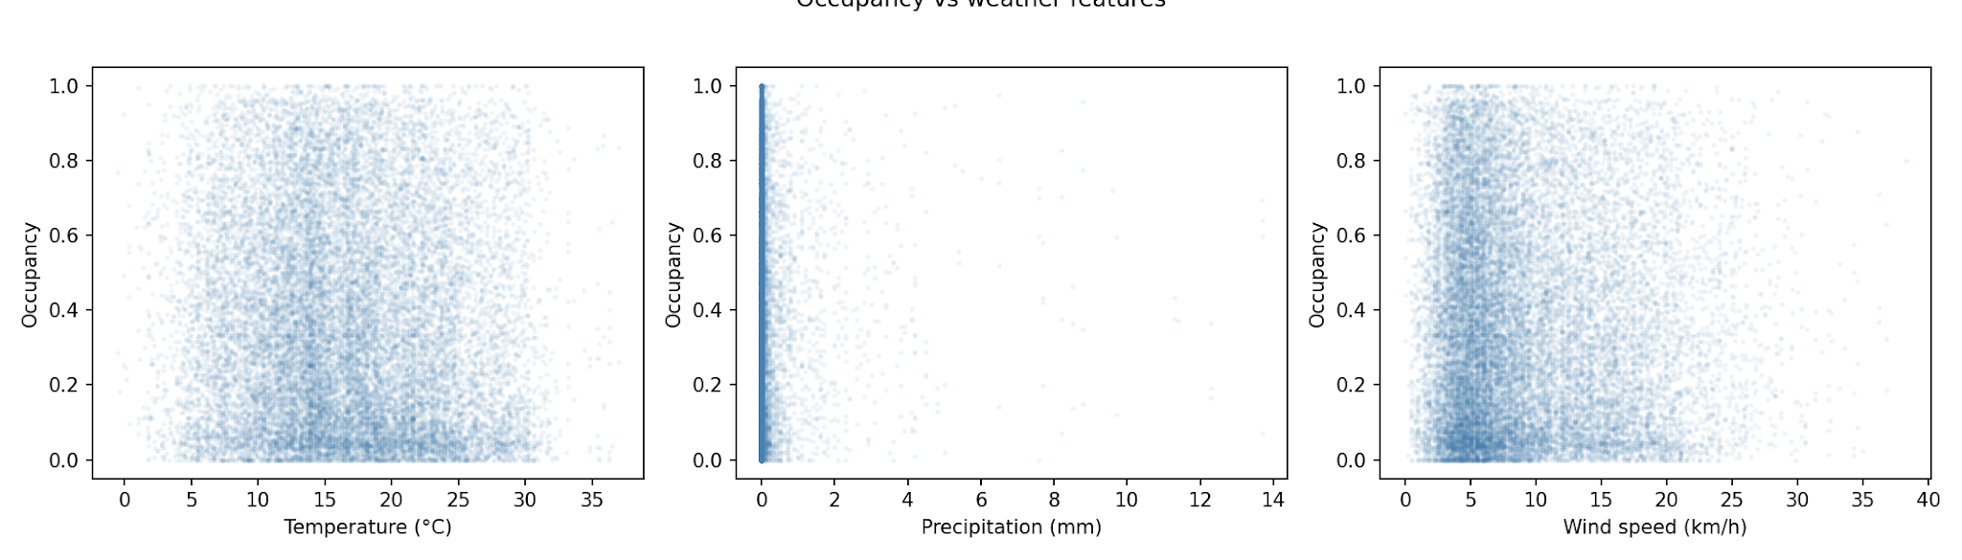
Figure 3. Occupancy vs. temperature, precipitation, and wind speed (20,000-point sample).
Weather effects are present but secondary to temporal patterns. Temperature shows a modest positive association with occupancy: more people cycle in mild weather. Precipitation and wind speed show weak negative associations. All three are included as features because their effects are non-negligible, particularly on marginal days.

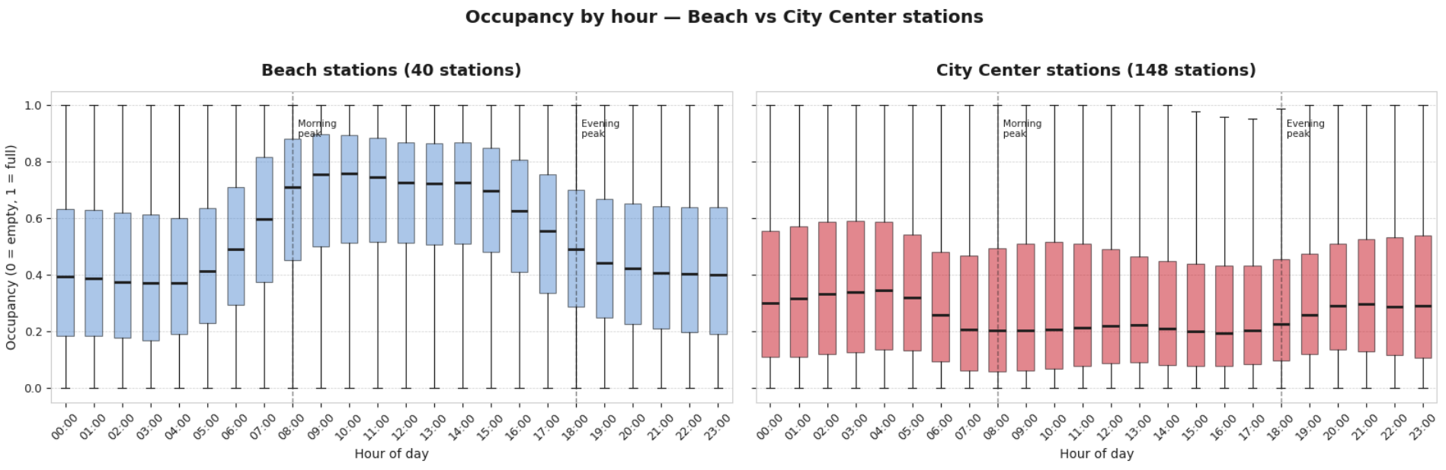
Geography drives fundamentally different occupancy patterns. As an example: beach stations (n=40) show high daytime occupancy peaking around 08:00–16:00, as cyclists ride to the seafront and leave their bikes parked at the station, then drop sharply at night when recreational demand disappears. City Center stations (n=148) show the opposite rhythm: occupancy falls during morning commuting hours (07:00–09:00), then recovers through the day as bikes are redistributed or returned. This contrast motivates including spatial distance features (dist_beach, dist_center) in the model rather than treating all 510 stations as homogeneous.

2.3 Attribute Analysis and Data Statistics
Target variable. target_occ is a continuous numeric value bounded to [0, 1], representing predicted station occupancy at a future horizon. Across the dataset, it has a mean of 0.37 and a standard deviation of 0.28, with a median of 0.32 and an interquartile range of [0.12, 0.58], confirming the right-skewed distribution previously discussed.
Occupancy features. current_occ, lag_24h, lag_168h, and rolling_mean_3h are all continuous values in [0, 1]. Their descriptive statistics are nearly identical (mean ~0.37, std ~0.27), which is expected since they all represent occupancy at different points in time for the same stations. hist_mean_occ is also bounded to [0, 1] but has a lower standard deviation (0.20) because it is a long-run average, smoothing out momentary fluctuations.
Station features. capacity is a numeric integer ranging from 12 to 54 docks, with a mean of 27 and a standard deviation of 6.5. dist_beach ranges from 0.03 to 9.26 km (mean 3.96 km) and dist_center from 0.04 to 8.34 km (mean 2.99 km); both are continuous, right-skewed, reflecting that most stations are within a few kilometres of central reference points.
Binary features. is_weekend takes values {0, 1}, with weekdays representing approximately 71.5% of observations and weekend days 28.5%. is_holiday takes values {0, 1}, with holidays representing roughly 3.6% of observations, consistent with the number of public holidays in Barcelona in 2024.
Ordinal feature. horizon_hours takes five ordered values: {1, 3, 6, 12, 24}, each representing a prediction horizon in hours. Each value accounts for approximately one-fifth of the dataset.
Cyclical temporal features. Hour of day, day of week, month, and target hour of day are each encoded as sin/cos pairs, yielding eight continuous features bounded to [−1, 1]. This encoding preserves the circular nature of time (e.g., hour 23 and hour 0 are adjacent) without introducing artificial ordinality.

2.4 Outlier Analysis and Strategy
A small number of raw records report more bikes than a station's listed capacity, likely due to API lag during rebalancing. These are handled at feature engineering time by clipping occupancy to [0, 1]. No aggressive outlier removal was applied beyond this.

2.5 Missing and Erroneous Data Strategy.
Stations that appear in the status files but not in the information file (38 unmatched stations) are dropped, as distance and capacity features cannot be computed for them.
The first week of data per station is dropped because lag_168h (the 168-hour lag) cannot be computed for it. This is a deliberate design choice: including rows with null lags would require imputation that could introduce bias, and the lost rows represent less than 2% of the total dataset.

3. Data Preparation

3.1 Data Cleansing Process
The pipeline starts by extracting the twelve monthly .7z archives from the Open Data BCN portal. Each extraction yields a station status file (ESTACIONS) and a station metadata file (INFORMACIO). The twelve status files are concatenated, filtered to IN_SERVICE records, and aggregated from 5-minute snapshots to hourly averages via a groupby on (station_id, datetime_hour). Hourly aggregation reduces noise from individual misreads and aligns the dataset to the granularity appropriate for forecasting at 1-24 hour horizons.
The station information file is loaded from January (station metadata is stable across the year) to obtain GPS coordinates and dock capacity. It is joined to the status data on station_id; 38 unmatched stations (less than 0.5% of records) are dropped. Occupancy is then computed as bikes_total / capacity, clipped to [0, 1]. The hourly weather series is joined on datetime_hour, completing the base dataset.

3.2 Feature Engineering
The feature set was designed with two objectives: provide enough signal to capture temporal and spatial patterns, and avoid leaking future information into the training set.
Cyclic time encoding: hour, day_of_week, and month are each encoded as sin/cos pairs rather than raw integers. This ensures the model treats 23:00 and 00:00 as adjacent rather than maximally distant, which is essential given the prominence of overnight occupancy transitions. The prediction target time (T + horizon_hours) is also encoded separately as target_hour_sin and target_hour_cos, so the model knows at what time of day it is predicting.
Day-type flags: is_weekend and is_holiday are binary indicators. Barcelona's two local holidays (Sant Jordi and La Merce) were added manually to the Catalan public holiday list since they affect cycling patterns similarly to national holidays.
Occupancy history: current_occ is the strongest single predictor for short horizons. lag_24h and lag_168h anchor the prediction to yesterday-same-time and last-week-same-time, respectively, capturing daily and weekly seasonality. rolling_mean_3h captures recent momentum in the three hours before T.
Historical baseline: hist_mean_occ is the long-run average for each (station, hour, day_of_week) group. To prevent data leakage, it is computed exclusively on training rows and then joined to the full dataset. Computing it on the full dataset would allow the model to see test-period occupancy patterns through this feature, artificially inflating performance.
Distance features: dist_beach and dist_center are great-circle distances computed via the Haversine formula from each station to Barceloneta beach and Plaça Catalunya. These encode location as a continuous gradient rather than one-hot encoding 510 station IDs, keeping the model generalisable.
Horizon expansion: each (station, T) row is replicated five times, once per horizon, with the corresponding target occupancy shifted h steps forward. Memory is managed by downcasting float64 to float32 and trimming to the required columns before expansion, keeping the final 20-million-row dataset at a manageable size.
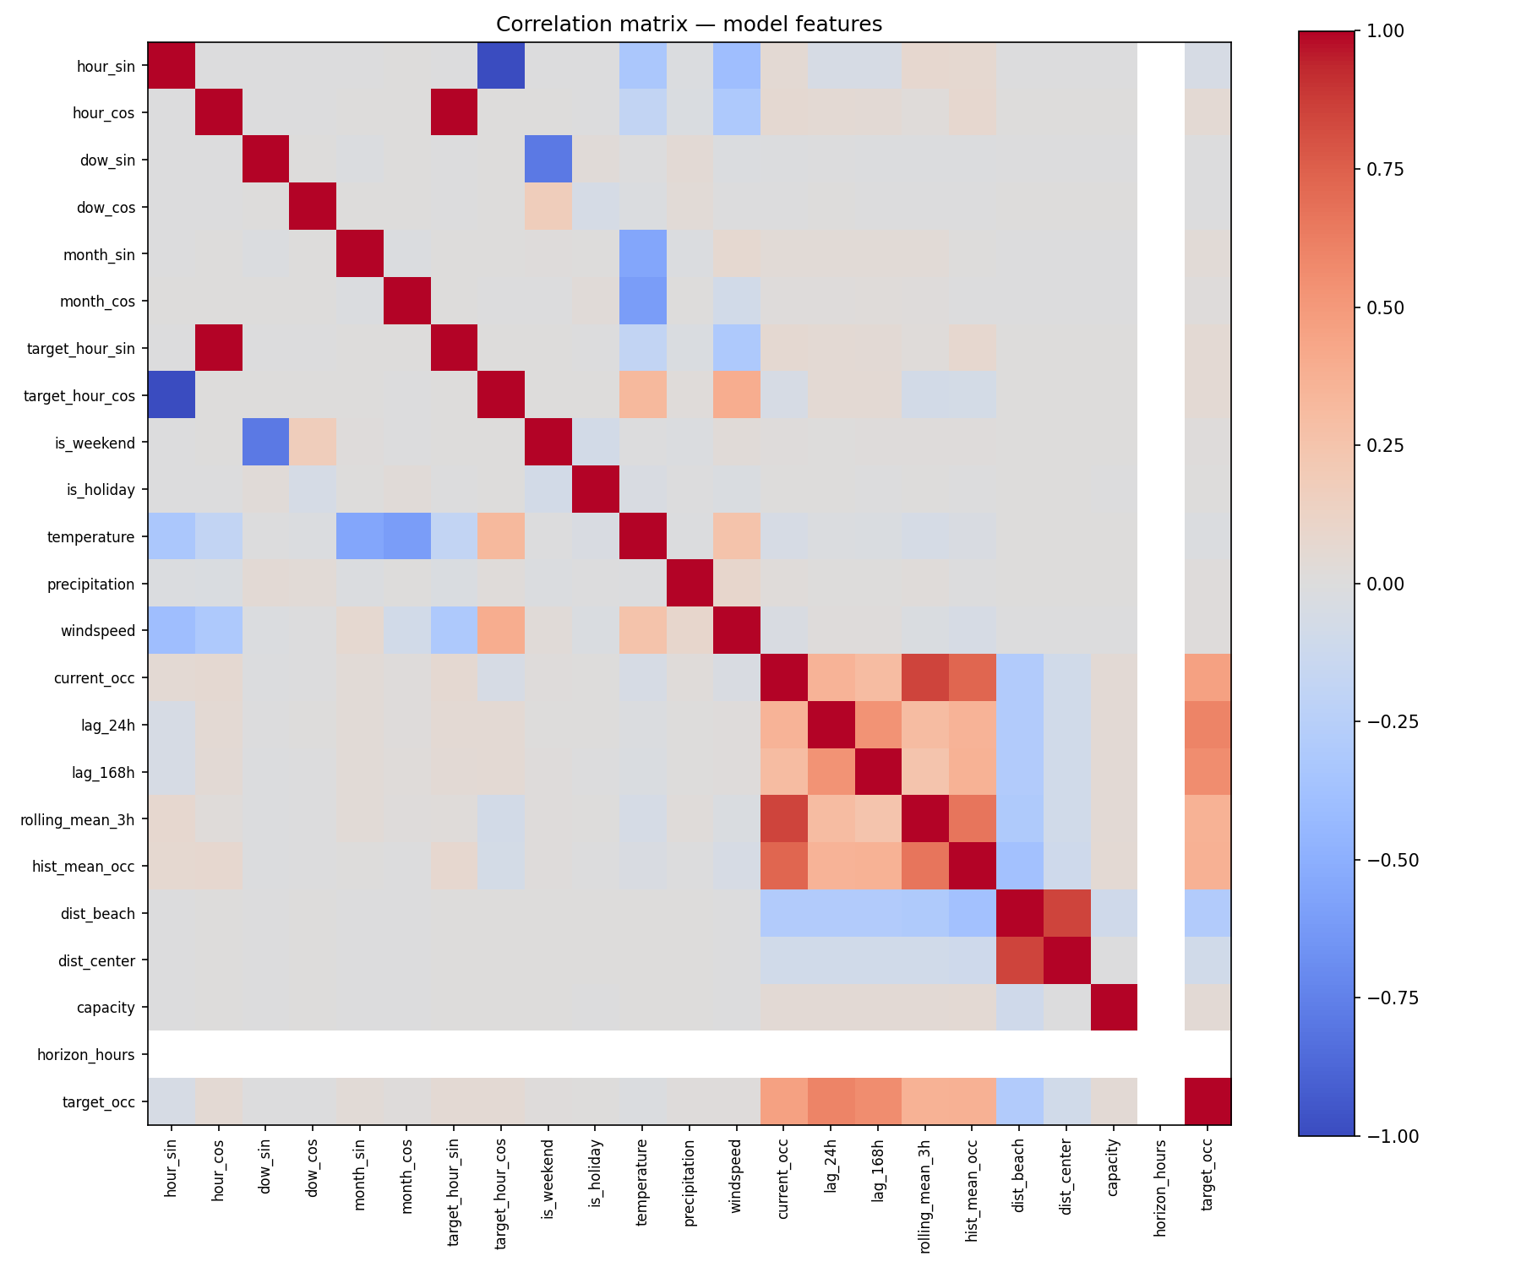
Figure 4. Pearson correlation matrix of model features and target. current_occ, hist_mean_occ, and the lag features show the strongest individual correlations with target_occ.
The correlation matrix confirms the design rationale. current_occ is the most correlated predictor (approximately 0.5 for a 6-hour horizon), followed by hist_mean_occ and the lag features. Cyclic and weather features show weaker individual correlations but add non-redundant signal that tree-based models can combine non-linearly.
The temporal train/test split is fixed at November 1, 2024. Training spans January 7 to October 31 (16,476,930 rows), and the test set covers November and December (3,665,100 rows).

4. Modelling

4.1 Task Type
This is a supervised multi-horizon regression problem. The target is a continuous fraction in [0, 1] representing future dock occupancy. Regression is appropriate because partial predictions (e.g., 0.65 occupancy) are operationally meaningful: they allow fleet managers to prioritise stations by severity rather than treating every alert as binary. The five horizons are handled by a single model that receives horizon_hours as a numeric feature, learning internally how uncertainty grows with distance into the future.

4.2 Model Selection
Three models were trained following a baseline-to-complex progression. Linear Regression establishes a performance floor: any model worth deploying must clearly beat it. Its coefficients also provide a sanity check on feature directions. Random Forest serves as a strong non-linear benchmark, capable of capturing interaction effects between features (e.g., a beach station on a hot Saturday versus a cold rainy Tuesday) that Linear Regression cannot represent. LightGBM is the primary candidate: gradient boosting consistently outperforms Random Forest on tabular data with mixed feature types, and it trains substantially faster, making a thorough hyperparameter search feasible within a reasonable timeframe.

4.3 Theoretical Introduction to the Models
Linear Regression fits a hyperplane through the feature space by minimising the sum of squared residuals. Inputs are standardized using a StandardScaler inside a scikit-learn Pipeline, ensuring the scaler is fit on training data only and applied consistently at inference. This is the only model for which this scaling step is required; tree-based models are invariant to monotonic feature transformations (Hastie et al., 2009; Pedregosa et al., 2011).
Random Forest is an ensemble of decision trees trained on bootstrapped subsets of the data. At each split, only a random subset of features is considered (controlled by max_features), reducing correlation between trees and improving generalisation. Predictions are averaged across all trees. The main complexity knobs are n_estimators (number of trees), max_depth (maximum tree depth), min_samples_split, and min_samples_leaf (regularisation via minimum node size) (Breiman, 2001).
LightGBM is a gradient boosting framework that builds trees sequentially, each correcting the residuals of the ensemble so far. Unlike depth-first boosting, LightGBM grows trees leaf-first (best-leaf splitting), producing deeper, more accurate trees for a given number of leaves. Key hyperparameters include: n_estimators (boosting rounds), num_leaves (primary complexity control), learning_rate (shrinkage per round), max_depth (safety cap), subsample and colsample_bytree (row and column subsampling per tree, acting as stochastic regularisation), and reg_alpha / reg_lambda (L1 and L2 leaf penalties). LightGBM also natively supports SHAP values through its TreeExplainer integration, enabling individual prediction explanations without post-hoc approximation (Friedman, 2001; Ke et al., 2017).

4.4 Hyperparameter Tuning
Hyperparameter search used RandomizedSearchCV with TimeSeriesSplit cross-validation (3 folds, one-week gap between each fold's train end and validation start). The gap prevents autocorrelation bleed-through: without it, the last hours of a training fold and the first hours of the next validation fold would be nearly identical, inflating CV scores (Bergstra & Bengio, 2012; Bergmeir & Benítez, 2012; Pedregosa et al., 2011).
Running a full search over 16.5 million training rows would take many hours per fit. A stratified 500,000-row sample (proportional across horizons, about 3% of the training data) was used for the search phase instead. CV estimates on this sample are stable enough to rank hyperparameter configurations. The winning configuration was then retrained on the full 16.5-million-row training set to capture the maximum available signal.
Best parameters found for Random Forest: n_estimators=300, max_depth=16, max_features=0.5, min_samples_split=20, min_samples_leaf=20.
Best parameters for LightGBM: n_estimators=200, num_leaves=63, learning_rate=0.12, max_depth=8, colsample_bytree=0.7, subsample=0.9, reg_alpha=0.05, reg_lambda=0.01, min_child_samples=100. The relatively conservative num_leaves and learning_rate suggest the search found a configuration that trades some peak accuracy for generalisation robustness, which is reflected in the small train-test RMSE gap.

5. Evaluation

5.1 Results
All models are evaluated on the November-December 2024 test set (3,665,100 rows). Three metrics are reported: RMSE (root mean squared error), MAE (mean absolute error), and R² (R-squared). The naive baselines are included as reference points.

Model | RMSE | MAE | R² | Infer. time (s)
Naive — Persistence | 0.2351 | 0.1601 | 0.2881 | —
Naive — Historical Mean | 0.2364 | 0.1841 | 0.2803 | —
Linear Regression | 0.1964 | 0.1529 | 0.5032 | 1.4
Random Forest | 0.1697 | 0.1306 | 0.6291 | 36.7
LightGBM (selected) | 0.1632 | 0.1235 | 0.6571 | 52.8
Table 1. Test-set performance. RMSE and MAE are on the [0, 1] occupancy scale. Inference time is for the full 3.6M-row test set.
All three ML models significantly outperform both naive baselines. LightGBM achieves the best result across every metric. Relative to the persistence baseline (RMSE 0.235), it reduces error by 31%. In operational terms, an MAE of 0.124 on a typical 33-dock station translates to roughly plus or minus 4 bikes, a margin small enough to make the predictions directly actionable.
The inference time column is relevant for deployment: LightGBM scores all 3.6M test rows in about 53 seconds, versus 37 seconds for Random Forest and 1.4 seconds for Linear Regression. For the deployed API use case (one prediction per station per minute, approximately 30,000 requests per minute), LightGBM inference on a single row takes under 1 ms, making latency a non-issue.

Horizon | LightGBM RMSE | Random Forest RMSE | Linear Reg. RMSE
1 h | 0.093 | 0.098 | 0.143
3 h | 0.150 | 0.154 | 0.170
6 h | 0.169 | 0.176 | 0.199
12 h | 0.194 | 0.209 | 0.249
24 h | 0.189 | 0.191 | 0.206
Table 2. RMSE by prediction horizon on the test set. LightGBM maintains an advantage at every horizon.
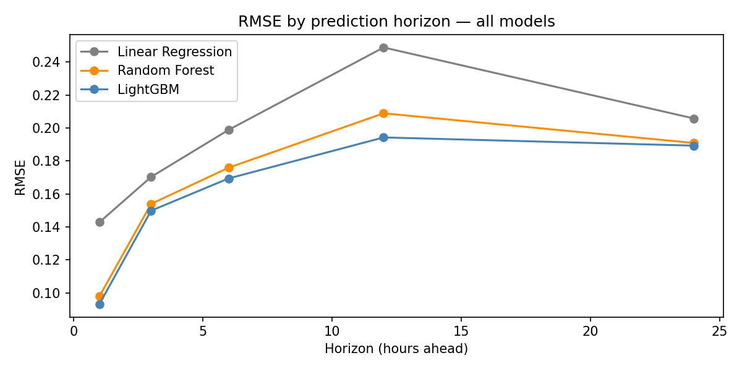
Figure 5. RMSE by horizon for all three models on the test set.
Error grows with prediction horizon as expected. One notable pattern is that 24-hour RMSE is slightly lower than 12-hour RMSE for all models. This is because at T+24h the model is essentially predicting "tomorrow same time" for which the lag_168h (same slot last week) and hist_mean_occ features provide strong direct signal. At T+12h the analogous historical anchors are less direct, making the prediction harder. This reflects a genuine property of the data, not a modelling artefact.
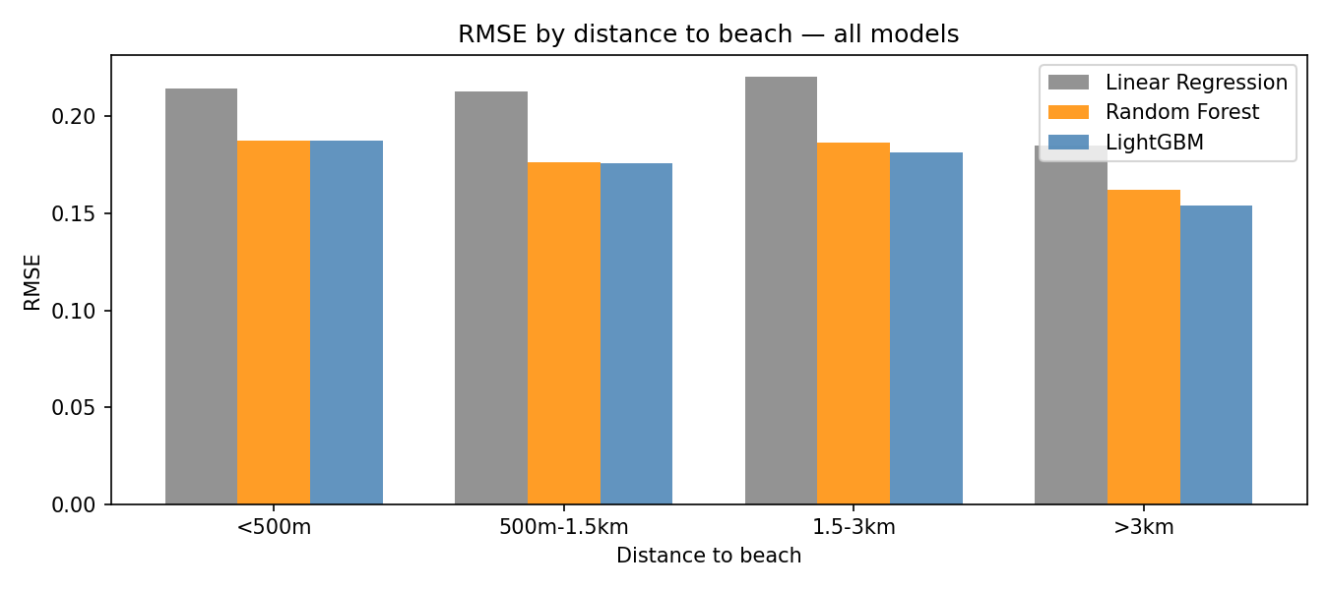
Figure 6. RMSE by distance to Barceloneta beach. Stations near the beach are harder to predict across all models.
Stations within 500 metres of the beach have the highest prediction error. These stations exhibit high seasonal variance: they are heavily used on warm summer weekends (tourist traffic) and nearly idle in winter. This pattern heterogeneity is difficult for a global model to capture without location-specific features. Stations further from the beach, serving a more stable commuter population, are predicted with consistently lower error.

5.2 Validation Against Business Objectives
The project's primary requirement was to outperform naive alternatives. LightGBM achieves an R² of 0.657 versus the persistence baseline's 0.288, a 128% improvement in explained variance. At the 1-hour horizon, where operational decisions are most urgent and actionable, RMSE drops to 0.093 (roughly plus or minus 3 bikes on a median station). The second requirement, explainability, is addressed by the SHAP analysis below.

5.3 Interpretation, Contextualisation, and Error Costs
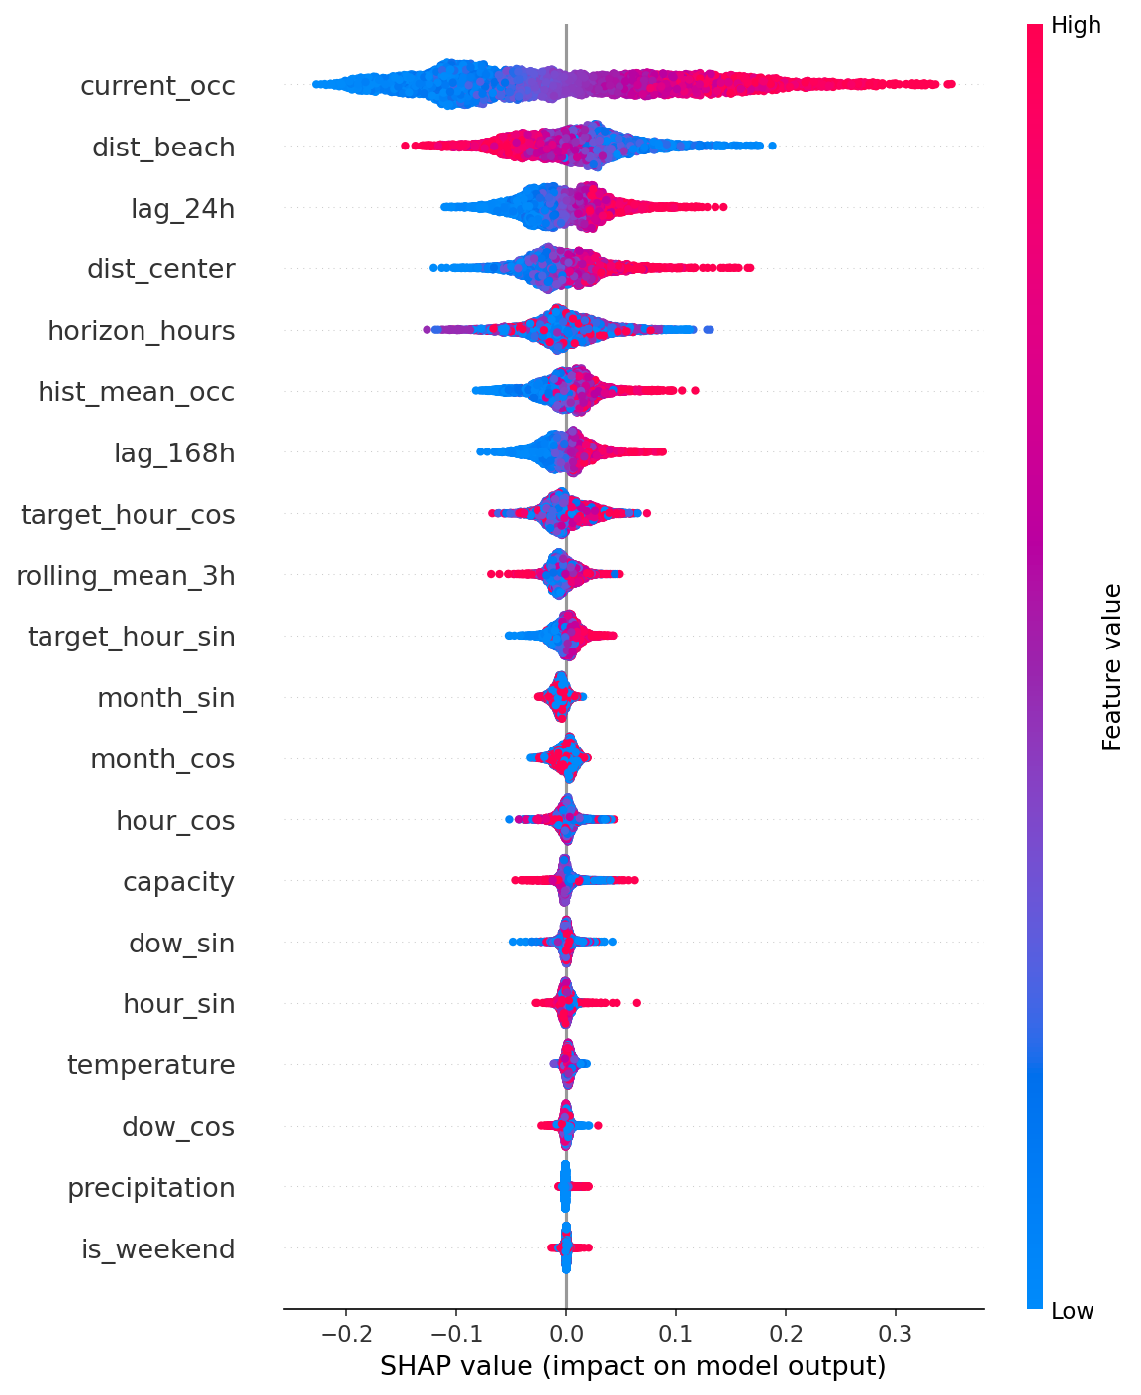
Figure 7. SHAP summary plot for LightGBM. Horizontal position shows each feature's marginal contribution to the prediction; colour shows whether the feature value is high (red) or low (blue).
The SHAP analysis makes the model's decision logic transparent (Lundberg & Lee, 2017). current_occ dominates at short horizons: the most recent reading is simply the best predictor of the near future. hist_mean_occ becomes relatively more important at longer horizons, when the short-term state of the station has decayed as a signal, and the model relies more on long-run patterns. The horizon_hours feature has a consistent negative effect: longer horizons produce lower predictions, reflecting the model's learned tendency to regress toward historical means as uncertainty grows. The lag features (lag_24h and lag_168h) provide the daily and weekly seasonality anchors. Weather features, particularly temperature, have modest but consistent effects in the expected direction.
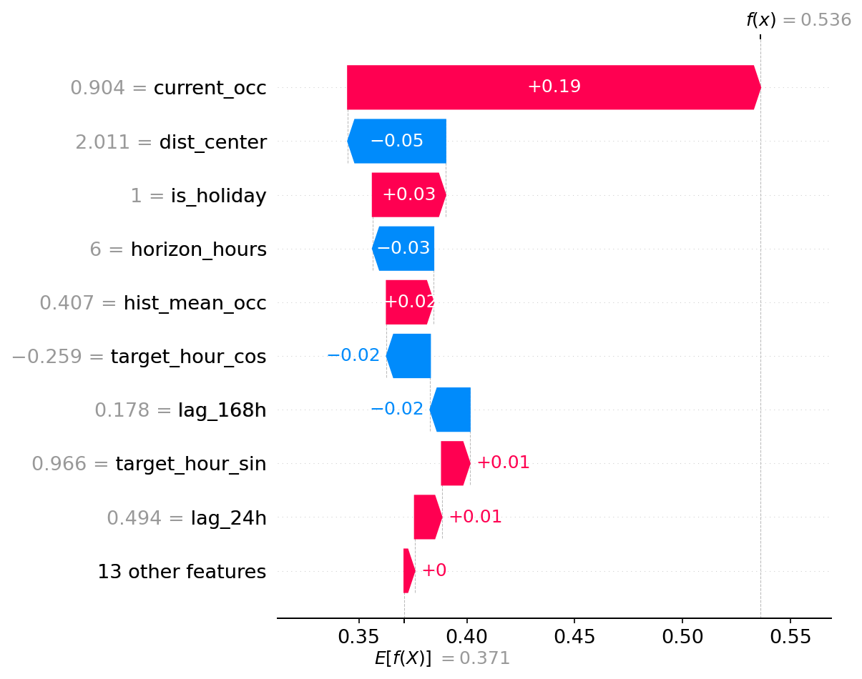
Figure 8. SHAP waterfall for a single prediction example. Starting from the dataset mean (0.37), each feature pushes the final prediction up or down.
The waterfall plot shows how the model arrives at a specific prediction. In this example, a high current occupancy pushes the prediction well above the base value, while a long prediction horizon and moderate historical baseline pull it back down. Operations dashboard: a fleet manager can see not just that a station is predicted to overflow, but which signals are driving the alert.
Regarding error costs, not all errors are equally costly. A false negative (predicting empty when the station will actually be full) at a major transit hub during morning rush hour is far more disruptive than the same error at a quiet peripheral station at midnight. The current model minimises global RMSE equally across all contexts. A natural extension would be to weight the loss function by station volume or hour of day, ensuring accuracy where it matters most operationally.

6. Model Iteration: LightGBM V2

6.1 Motivation
The V1 LightGBM model achieved a test RMSE of 0.1632 and R² of 0.657. While these results clearly outperform all baselines, the SHAP analysis showed that current_occ and hist_mean_occ were doing most of the predictive work, and the model had limited short-range temporal resolution: the shortest lag available was lag_24h. This motivated a second iteration to see if better feature engineering and hyperparameter search would improve the first version results.

6.2 Feature Engineering Changes (V2)
The V2 pipeline adds eight new features and removes three that were redundant, bringing the total feature count from 22 to 27.
Features added: lag_1h, lag_2h, and lag_3h provide sub-daily occupancy history in the hours immediately before T, filling the resolution gap between current_occ and lag_24h. lag_48h adds a two-day lag as an intermediate anchor. rolling_mean_6h and rolling_mean_24h extend the rolling window coverage beyond the original 3-hour window, capturing slower trends. neighbor_mean_occ is the mean occupancy of the 5 nearest stations at time T, computed via great-circle distances; it encodes local network context and captures spillover effects when nearby stations are filling up simultaneously. is_holiday_tomorrow is a binary flag indicating whether the following day is a public holiday, providing forward-looking calendar signal unavailable in V1.
Features removed: is_weekend was dropped because the cyclic day-of-week encoding (dow_sin, dow_cos) already distinguishes weekdays from weekends continuously. month_sin and month_cos were removed because their seasonal signal is largely subsumed by hist_mean_occ, which encodes station-level monthly patterns.

6.3 Hyperparameter Search: Two-Phase Optuna
The V2 hyperparameter search replaced RandomizedSearchCV with a two-phase Optuna search (Akiba et al., 2019). Optuna uses a Tree-structured Parzen Estimator (TPE) sampler that models the objective function probabilistically and directs trials toward promising regions, making it more sample-efficient than random search.
Phase 1 ran 60 trials over a wide search space (n_estimators 200–500, num_leaves 31–127, learning_rate 0.02–0.15 on a log scale, subsample and colsample_bytree 0.5–1.0, min_child_samples 20–200, L1/L2 penalties). The best Phase 1 configuration achieved a CV RMSE of 0.1727 on the 500,000-row stratified search sample. Phase 2 ran 10 additional trials within a ±30% window around the Phase 1 best parameters, fixing max_depth to 20. Phase 2 confirmed the same CV RMSE of 0.1727, indicating Phase 1 had already converged. Both phases used TimeSeriesSplit with 3 folds and a one-week gap.
Final V2 parameters: n_estimators=472, num_leaves=113, max_depth=20, learning_rate=0.060, subsample=0.538, colsample_bytree=0.874, min_child_samples=173, reg_alpha=0.072, reg_lambda=0.192.

6.4 Results
The V2 model was retrained on the full 16,476,930-row training set using the Phase 2 best parameters and evaluated on the same November-December test set.
V2 vs V1 on the test set: RMSE 0.1603 vs 0.1632 (−0.0029), MAE 0.1211 vs 0.1235 (−0.0024), R² 0.6693 vs 0.6571 (+0.0122). In operational terms, average error per station dropped from ±5.3 bikes to ±5.2 bikes on a typical 27-dock station.
The gains are consistent but modest. The additional short-range lags and neighbor_mean_occ provide genuine signal, but current_occ, hist_mean_occ, and lag_168h remain the dominant predictors. This suggests the main remaining source of error is irreducible variance: occupancy at longer horizons is genuinely uncertain, and no set of historically derived features can fully resolve it. LightGBM V2 is selected as the final deployed model.

7. Deployment

7.1 Proposed Production Architecture
The trained LightGBM model is serialised with joblib as models/final_model.joblib. The following describes a production architecture designed around this artifact. The implementation is designed but not built; the goal is to demonstrate that the modelling decisions were made with deployment in mind from the start.
The service exposes a REST API built with FastAPI. A client sends a POST request to /predict with three fields: station_id, datetime (ISO-8601), and horizon_hours. The service fetches the weather forecast for the target time from the Open-Meteo API, caching responses with a one hour TTL to avoid hammering the external endpoint (weather forecasts change slowly, and the free tier has rate limits). The feature vector is assembled, model.predict() is called, and the predicted occupancy is returned alongside the target datetime.
The model is loaded once at application startup via joblib.load(). Loading on each request would add one to two seconds of latency. The service is packaged as a Docker image using a Python 3.11 slim base, ensuring reproducibility across environments. At the network scale of Bicing (510 stations, one request per station per minute), a single FastAPI instance with a preloaded LightGBM model comfortably handles the load. If horizontal scaling were required, the model artifact could be stored in object storage (e.g., S3) and pulled at container startup, with multiple instances behind a load balancer.

7.2 Model Usage
The first intended mode of use is analyst-assisted. An operations dashboard would display a map of Barcelona at the start of each shift, with stations colour-coded by predicted occupancy at a chosen future horizon. Fleet managers would review stations expected to overflow or run dry and plan rebalancing routes accordingly, converting a reactive process into a proactive one.
A fully automatic mode, where predictions directly trigger dispatch orders without human review, is technically feasible but would require an additional confidence-thresholding layer and human oversight protocols before it could be trusted for routine operations.
A second mode targets end users directly through the public-facing app. At any point, a rider could query predicted availability at a nearby station for a chosen horizon. The model output would be surfaced as a simple availability indicator rather than a raw occupancy fraction, lowering the interpretation barrier for non-technical users. This mode places stricter latency requirements on inference and would benefit from pre-computing predictions at regular intervals rather than generating them on demand.

7.3 Model Evolution and Monitoring
The model is expected to degrade over time as urban cycling patterns change: new infrastructure, shifts in office locations, major events, and population changes can all alter demand in ways the 2024 training data does not capture. The proposed retraining cadence is monthly. Each retraining cycle runs the feature engineering pipeline with an updated split date (all available data minus the last two months as training), retrains LightGBM, compares test RMSE against the currently deployed model, and replaces the serialised artifact if performance improves.
Monitoring in production should track the distribution of predicted versus actual occupancy (requiring that prediction inputs and eventual outcomes are logged together) and alert when input feature distributions shift significantly relative to the training distribution. If occupancy patterns at a cluster of stations start diverging from historical norms, that is a signal to investigate whether a targeted retraining is warranted before the next scheduled cycle.

References
Akiba, T., Sano, S., Yanase, T., Ohta, T., & Koyama, M. (2019). Optuna: A next-generation hyperparameter optimization framework. In Proceedings of the 25th ACM SIGKDD International Conference on Knowledge Discovery & Data Mining (pp. 2623–2631).

Bergmeir, C., & Benítez, J. M. (2012). On the use of cross-validation for time series predictor evaluation. Information Sciences, 191, 192–213.

Bergstra, J., & Bengio, Y. (2012). Random search for hyper-parameter optimization. Journal of Machine Learning Research, 13, 281–305.

Breiman, L. (2001). Random forests. Machine Learning, 45(1), 5–32.

Friedman, J. H. (2001). Greedy function approximation: A gradient boosting machine. Annals of Statistics, 29(5), 1189–1232.

Hastie, T., Tibshirani, R., & Friedman, J. (2009). The elements of statistical learning: Data mining, inference, and prediction (2nd ed.). Springer.

Ke, G., Meng, Q., Finley, T., Wang, T., Chen, W., Ma, W., Ye, Q., & Liu, T.-Y. (2017). LightGBM: A highly efficient gradient boosting decision tree. Advances in Neural Information Processing Systems, 30.

Lundberg, S. M., & Lee, S.-I. (2017). A unified approach to interpreting model predictions. Advances in Neural Information Processing Systems, 30.

Pedregosa, F., Varoquaux, G., Gramfort, A., Michel, V., Thirion, B., Grisel, O., Blondel, M., Prettenhofer, P., Weiss, R., Dubourg, V., Vanderplas, J., Passos, A., Cournapeau, D., Brucher, M., Perrot, M., & Duchesnay, E. (2011). Scikit-learn: Machine learning in Python. Journal of Machine Learning Research, 12, 2825–2830.

Zippenfenig, P. (2023). Open-Meteo.com weather API [Computer software]. Zenodo.

